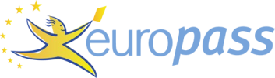
Curriculum vitae

PERSONAL INFORMATION Qibrie Rama

Ballanc, 61000 (Kosovo)

Sex Female | Date of birth 02/08/1999| Nationality Kosovar

EDUCATION AND TRAINING

01/09/2014–01/06/2017 Gymnasium of Natural Science

Gymnasium "Kuvendi i Lezhës" Flaka e Janarit, 61000 Viti (Kosovo)
Key subjects:
- English,Mathematics,Physics,Chemistry,Biology and Technology.
01/10/2019–Present
University of “Kadri Zeka’’
University of “Kadri Zeka”
University of “Kadri Zeka”
Juridik
University of “Hasan Prishtina”

PERSONAL SKILLS

Mother tongue(s) Albanian

Foreign language(s)
UNDERSTANDING |  | SPEAKING |  | WRITING
Listening | Reading | Spoken interaction | Spoken production

English B1 B1 A2 B1 B1
Levels: A1 and A2: Basic user - B1 and B2: Independent user - C1 and C2: Proficient user

18/01/22 © European Union, 2002-2020 | http://europass.cedefop.europa.eu Page 1 / 1

